**QUIZ APPLICATION**

Mini Project report submitted as a part of the academics of Third year

In

**INFORMATION TECHNOLOGY**

Affiliated to



Dr. Babasaheb Ambedkar Technological University, Lonere

By

**Jatte Aditi Mallinath**

T.Y IT Roll No.49

Under the Guidance of

**Prof.O.M.Patil**



**M.S.Bidve Engineering College, Latur.**

**2023-2024**

**CERTIFICATE**

This is to certify that **Ms. Jatte Aditi Mallinath** has successfully completed her mini project report on **Quiz Application** as a part of the academics for Third Year of the Degree in Information Technology and Engineering as prescribed by Dr .Babasaheb Ambedkar Technological University, Lonere during academic year 2023-2024.

Supervisor

Prof.O.M.Patil

Prof.D.V.Biradar Prof.B.V.Dharane

Head of IT Department Principle

**ABSTRACT**

The "Quiz Application using Core Java, Swing, and AWT" is a software solution developed to facilitate the creation, administration, and participation in quizzes within an educational context. This desktop application is built using the Java programming language, employing the Swing and AWT libraries for crafting an intuitive and interactive graphical user interface (GUI). The application serves both educators and students, enabling educators to generate quizzes and students to engage with them in an organized manner.

The primary components of the application encompass user authentication, quiz creation, administration, quiz-taking, scoring, and GUI design. The authentication mechanism allows users to create accounts or log in using their credentials, distinguishing between educators and students. Educators possess the capability to design quizzes by inputting questions, choices, and correct answers. The application affords an interface for structuring and managing the elements of the quizzes, which can be categorized according to subject matter or topics.

**CONTENTS**

1. Abstract 3
2. Acknowledgement 5
3. Introduction 6
4. Requirements 7
5. Flowchart 9
6. Code of Project 10
7. Output 20
8. Future Scope 26
9. Conclusion 27

**ACKNOWLEDGEMENT**

The satisfaction that accompanies that the successful completion of my task would be incomplete without the mention of people whose caseless cooperation made it possible, whose constant guidance and encouragement crown all efforts with success.

It is my acknowledge you that I have received a project on Quiz Application from my Teacher.

I am very grateful to my project supervisor **Prof. O. M. Patil** for the guidance, inspiration and constructive suggestions. During making of my project, he helped me a lot.

Finally, I wish to say thanks to all co-helper for helping me a lot.

Thank you!!

**INTRODUCTION**

The ‘MCQ Quiz Application’ project will be developed to overcome the time consuming problem of manual system. Apart from that in current system, checking the answer sheets after taking test, waste the examiners time, so this application will check the correct answer and save the examiner time and carry the examination in an effective manner. The users which are use this system don’t need to high computing knowledge and also system will inform them while entering invalid data.

The aim of this project is to computerized the existing manual system and help the examiners to save their valuable time and important data. Apart from this, data which are exist in this system,will exist for long period of time and will be easy accessible. This project helps the examiners to manage their services in a good way and provide a better service to their users.

**Requirement**

* **Hardware Requirements**:

1. **Processor**

* A modern multi-core processor, such as an Intel Core i5 or equivalent, is

recommended.

1. **Memory**

* A minimum of 4GB RAM is recommended for running the application smoothly.
* For improved performance, especially when dealing with larger datasets or multiple

users, 8GB or more is preferable.

1. **Operating System**

* The application can run on various operating systems that support Java, such as

Windows, macOS, and Linux.

* Windows 10
* **Software Requirements:**

1. **Java Development Kit (JDK):**

* The core requirement for developing and running Java applications.
* The application should be compatible with JDK 8 or later versions, though using the

latest version is recommended for security and performance improvements.

1. **Integrated Development Environment (IDE):**

* An IDE provides tools for coding, debugging, and building the application.
* Popular Java IDEs include Eclipse, IntelliJ IDEA, and NetBeans.

1. **Swing and AWT Libraries:**

* These are included in the Java Standard Edition and provide graphical user interface

components and tools.

* Ensure that the Swing and AWT libraries are available in your Java installation.
* **Used Technologies:**
* Java
* Swing
* AWT (Abstract Window Toolkit)

**FLOWCHART**

**50-50 lifeline**

**Cancel 2 option**

**Next Quiz**

**Start Quiz**

**Registered?**

**Login**

**Code of project:**

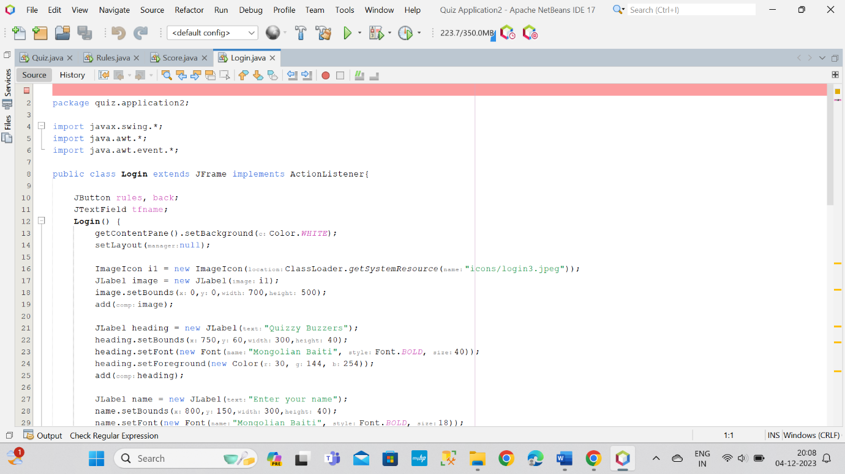

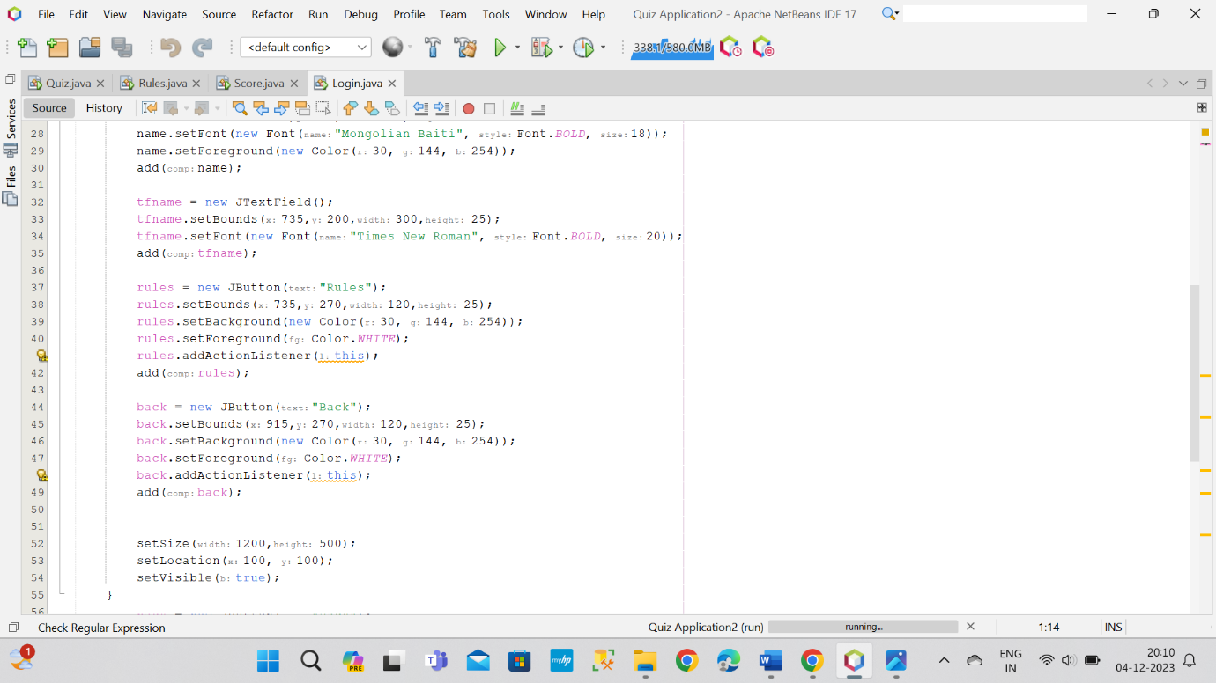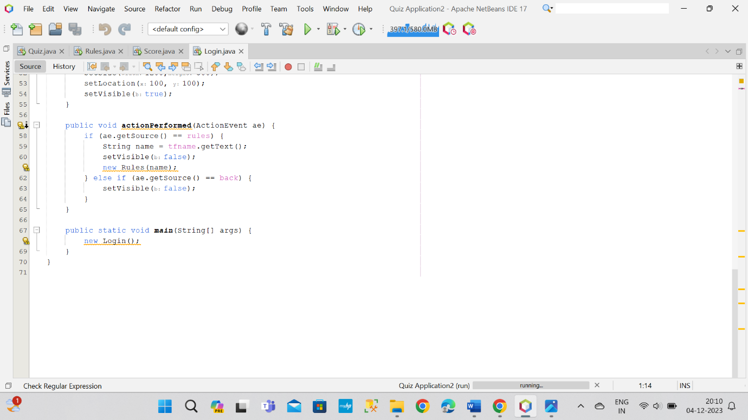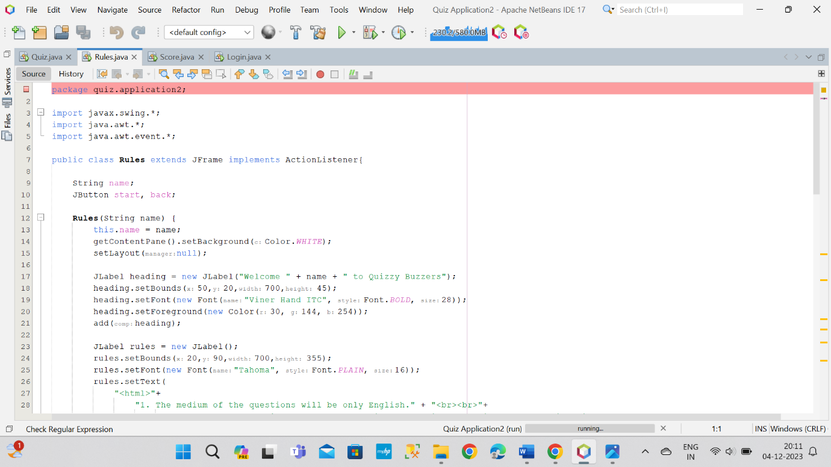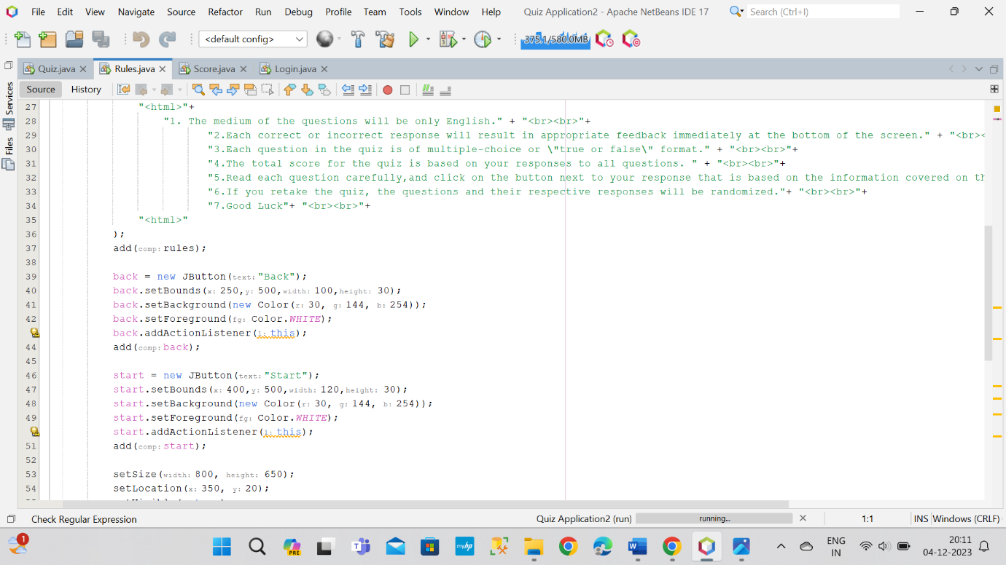

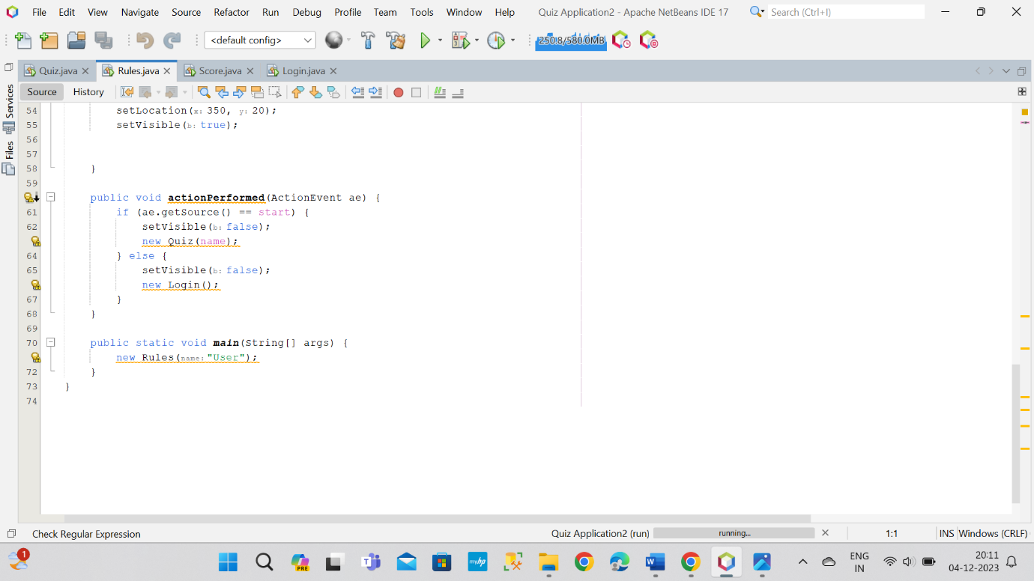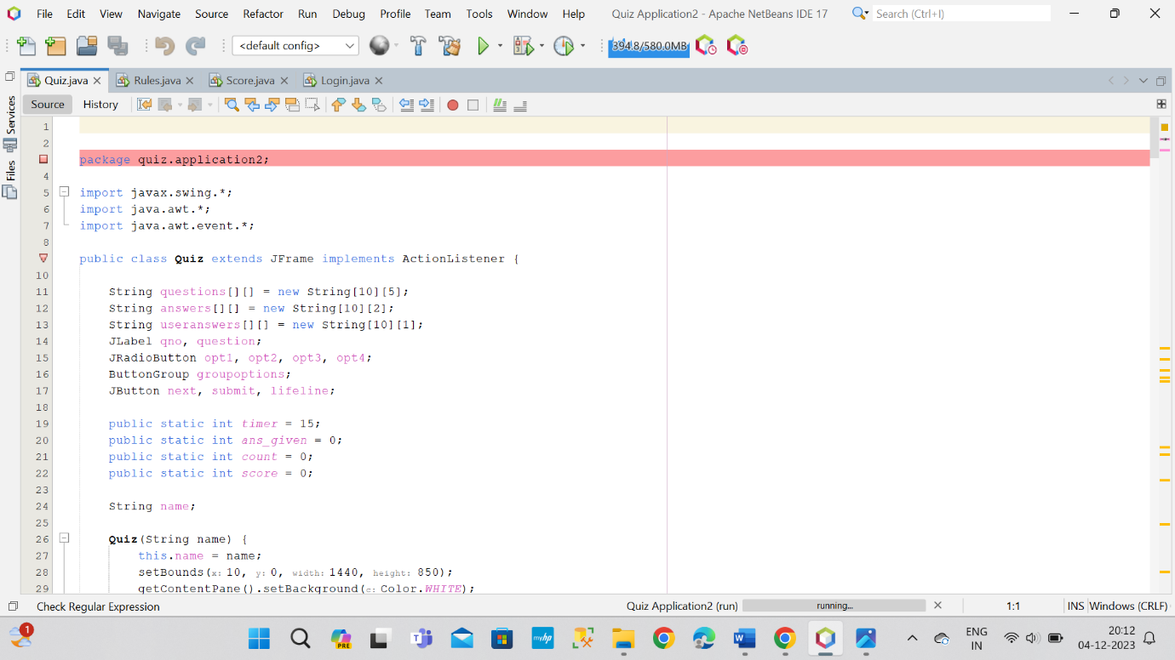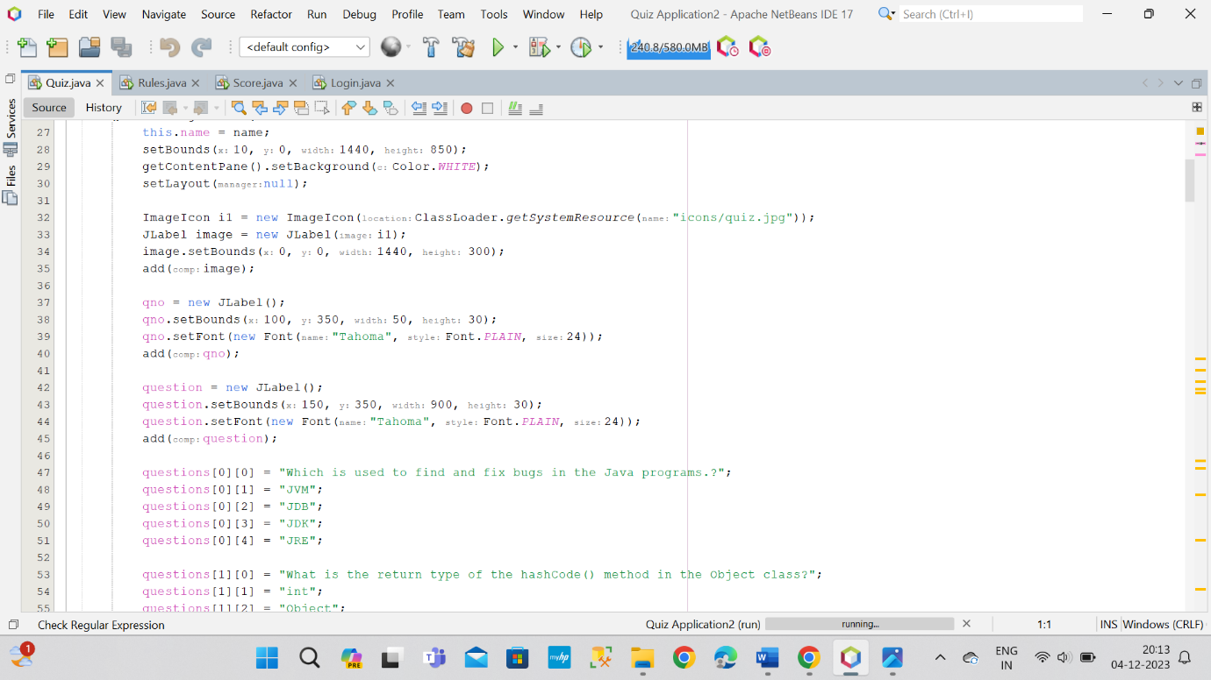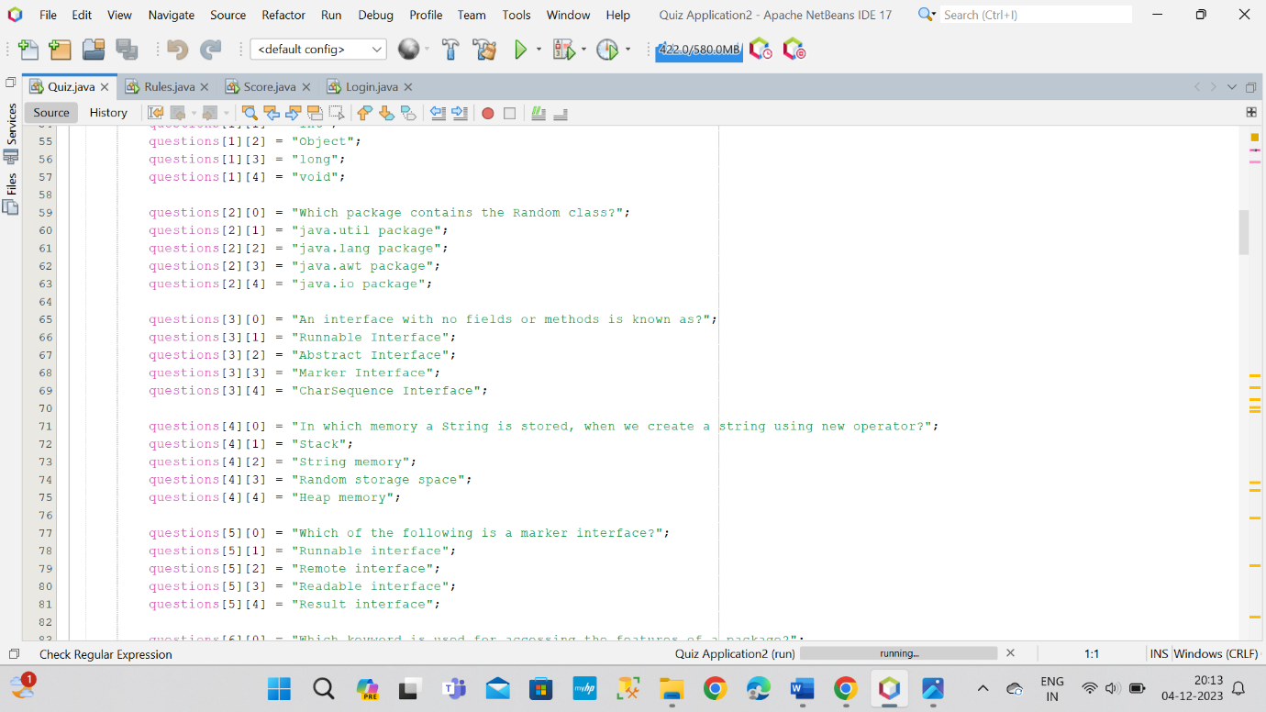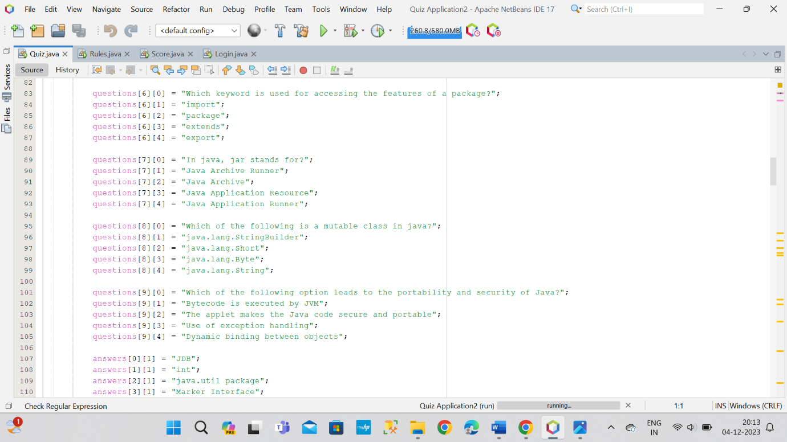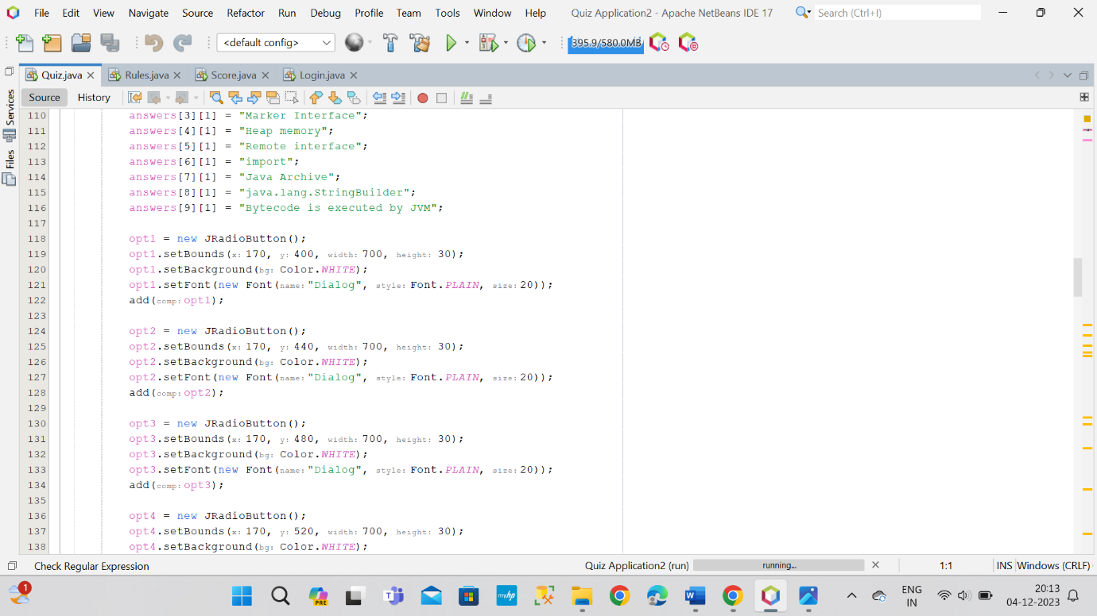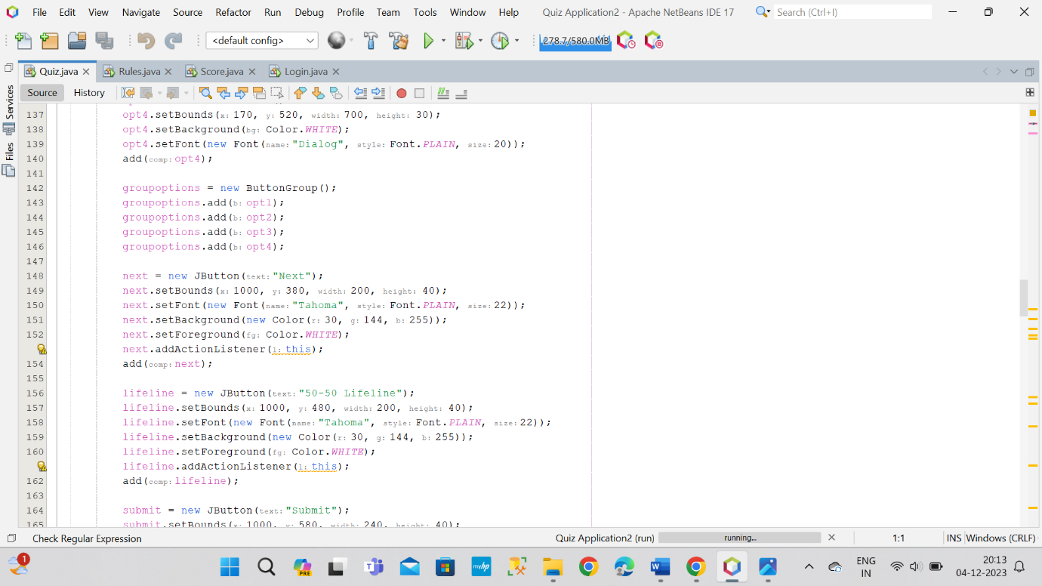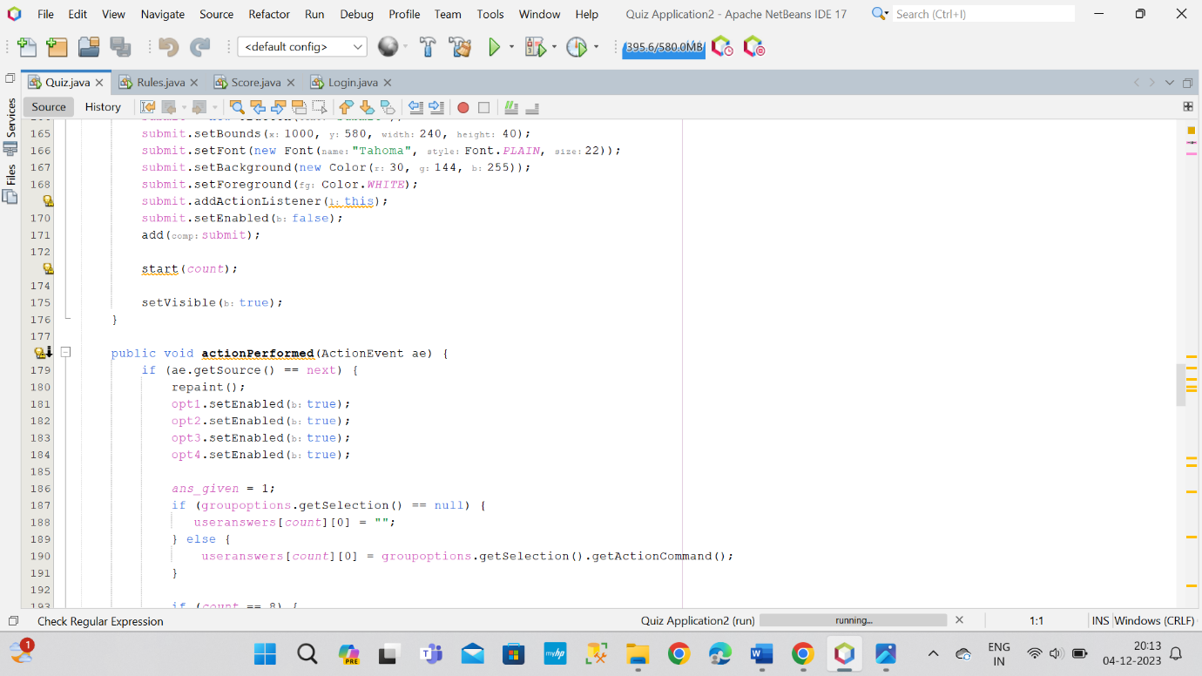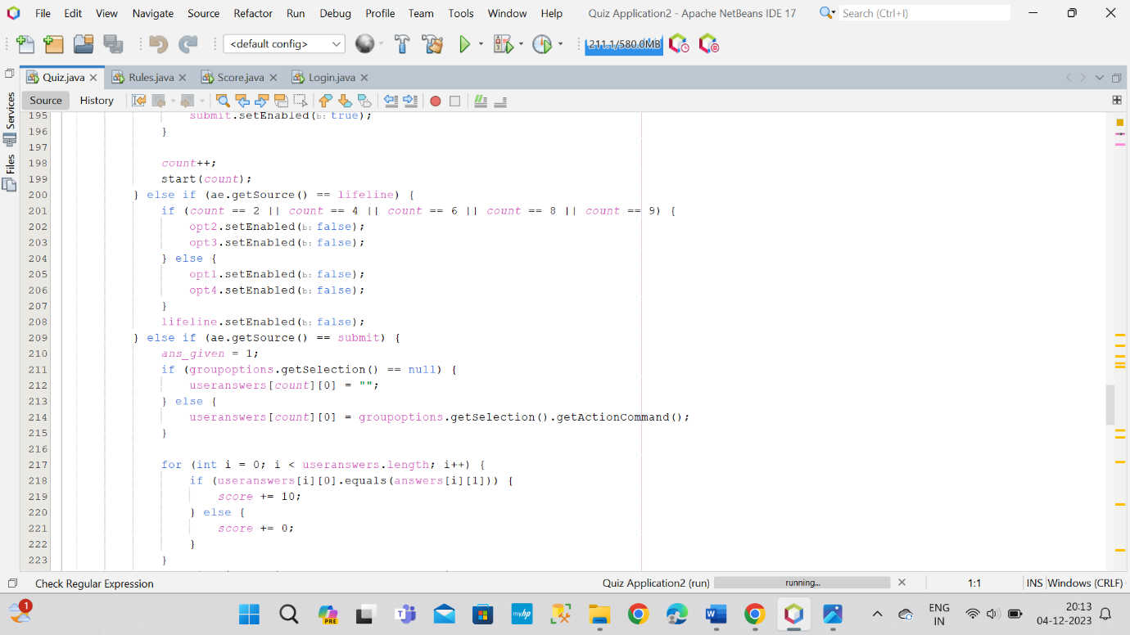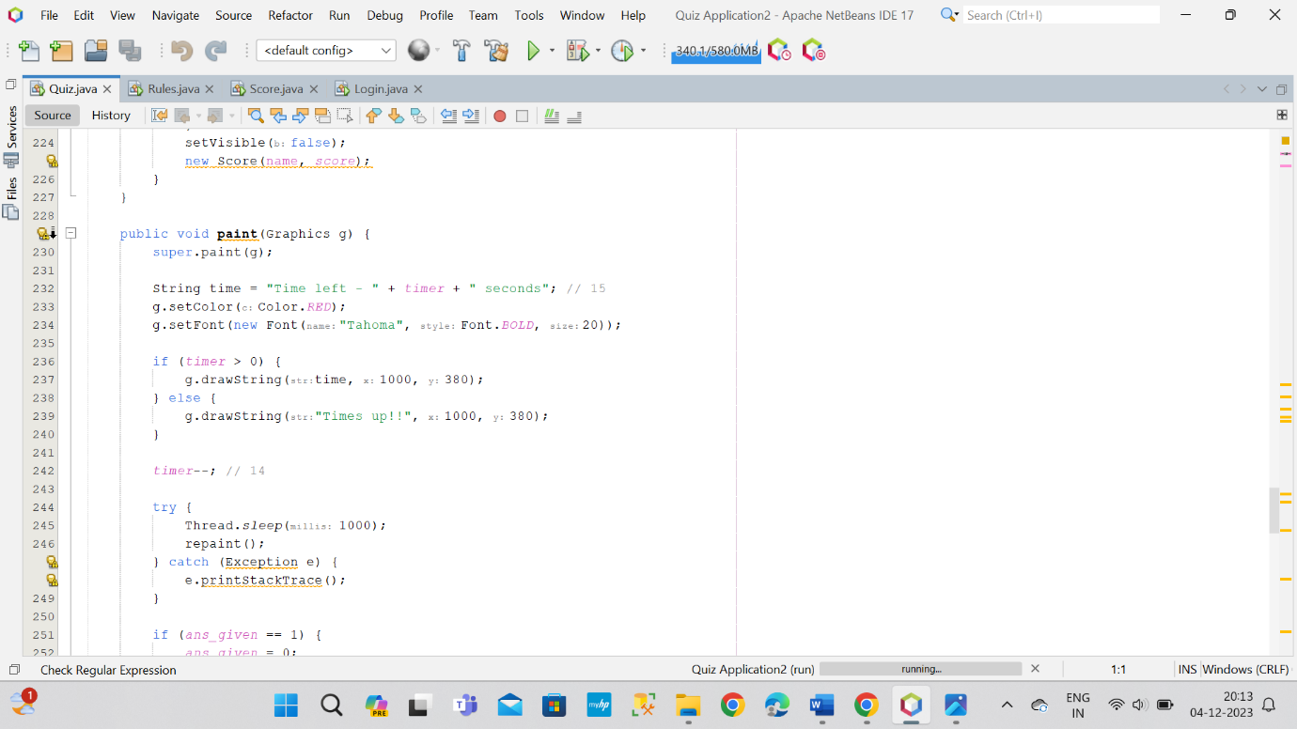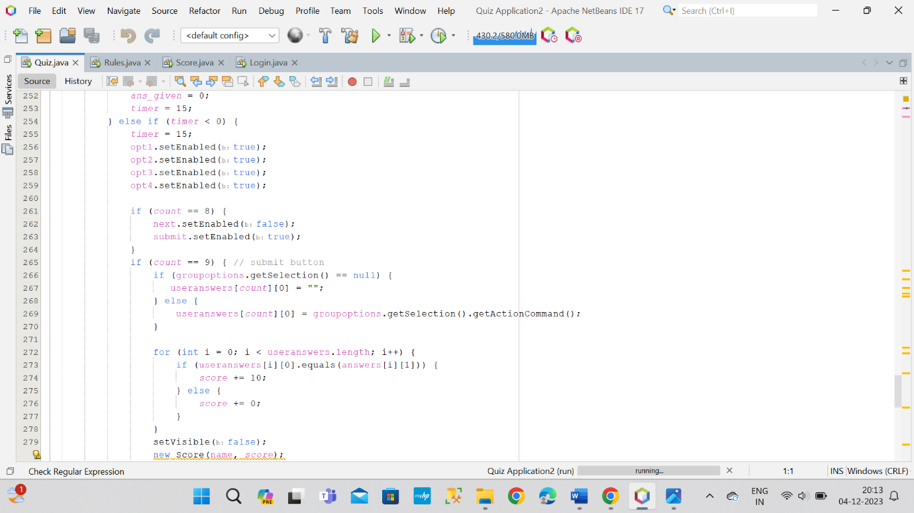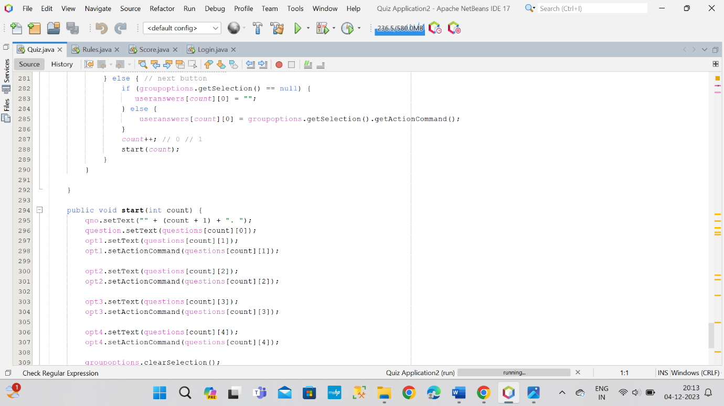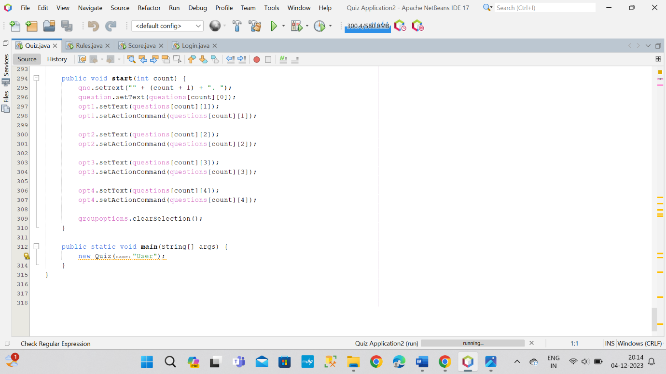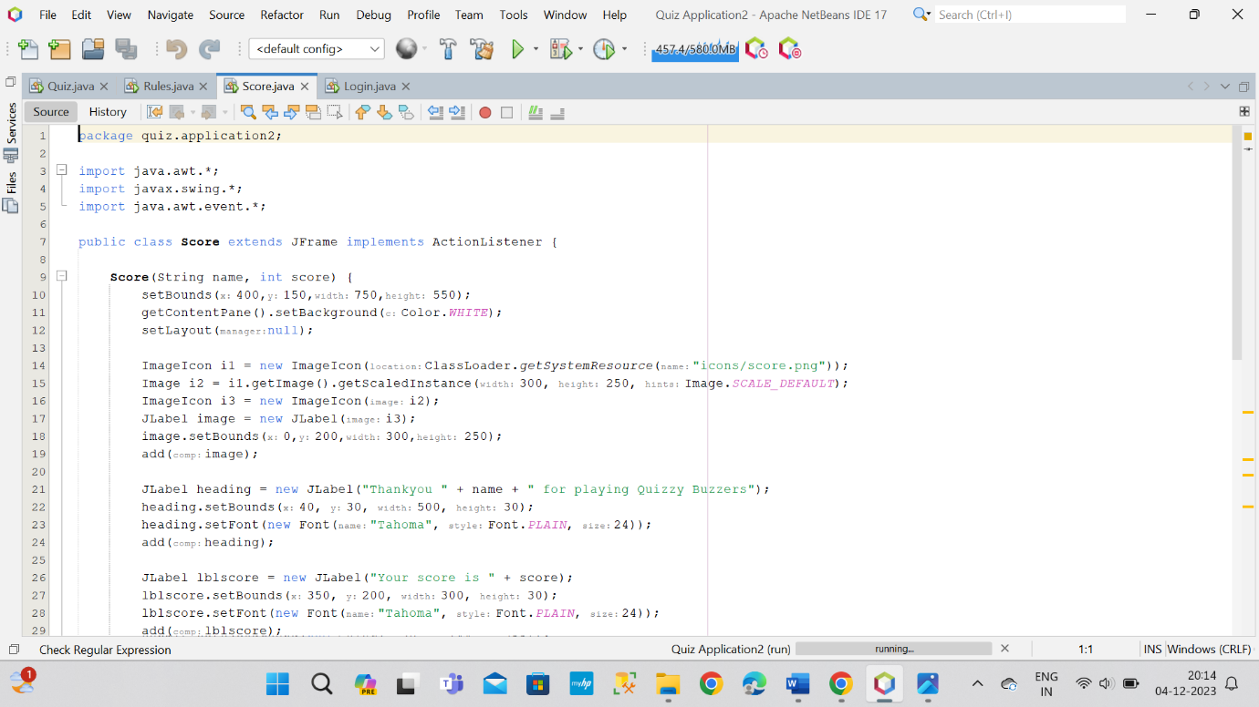

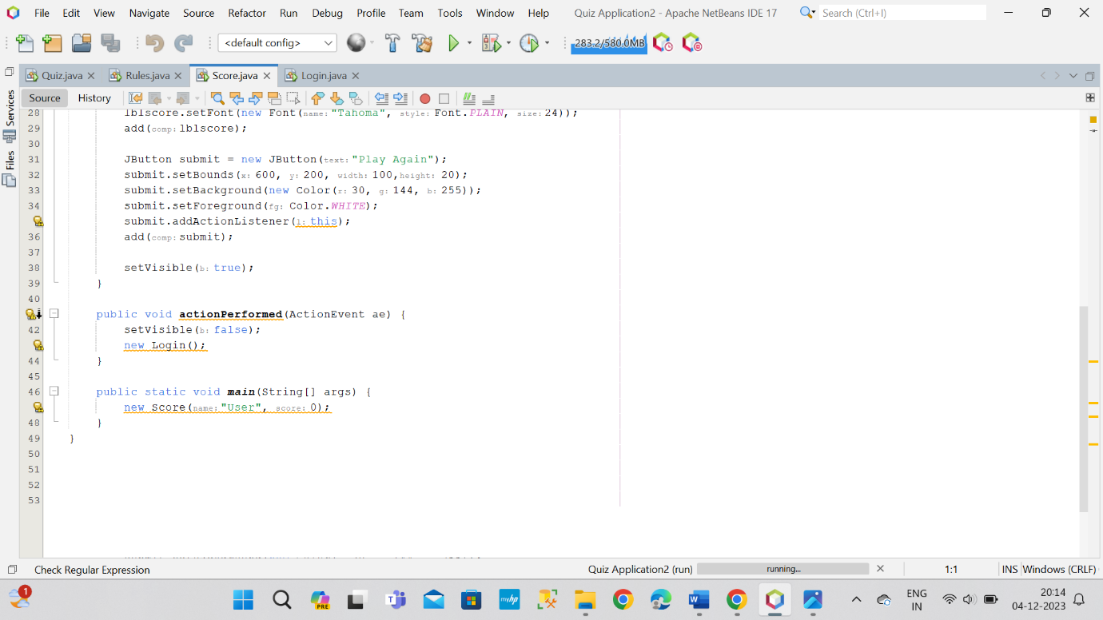

**OUTPUT**

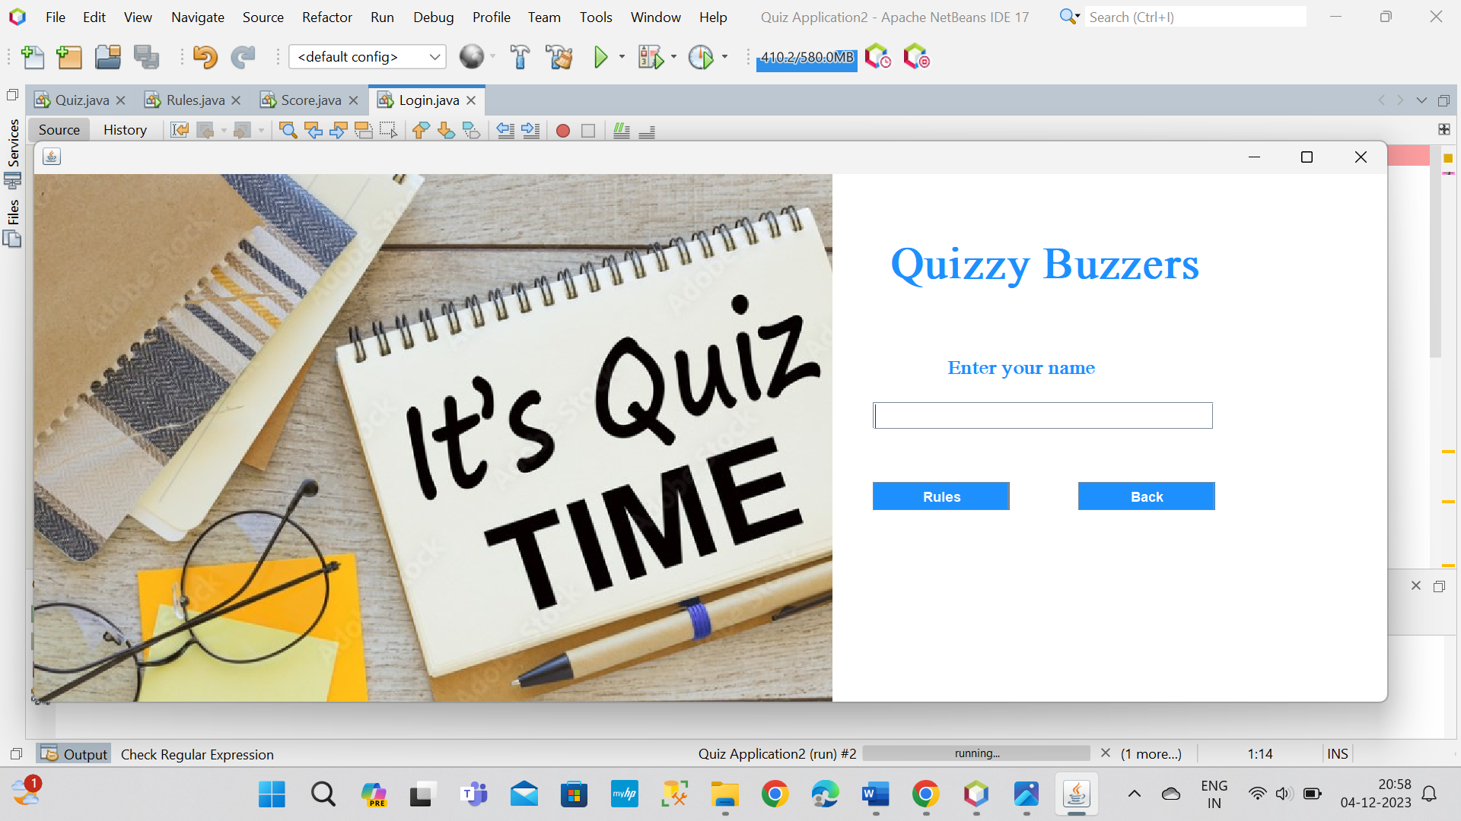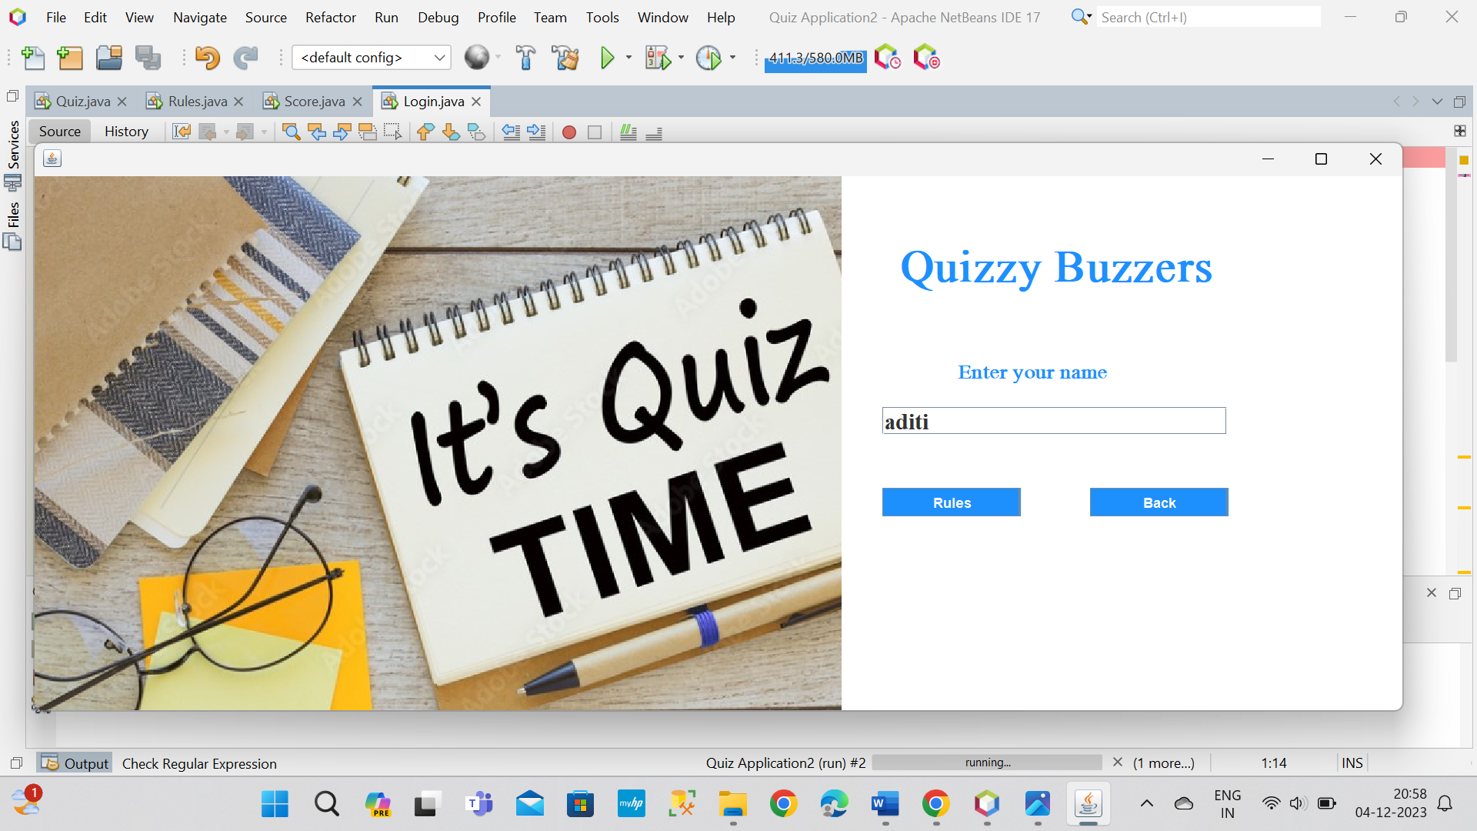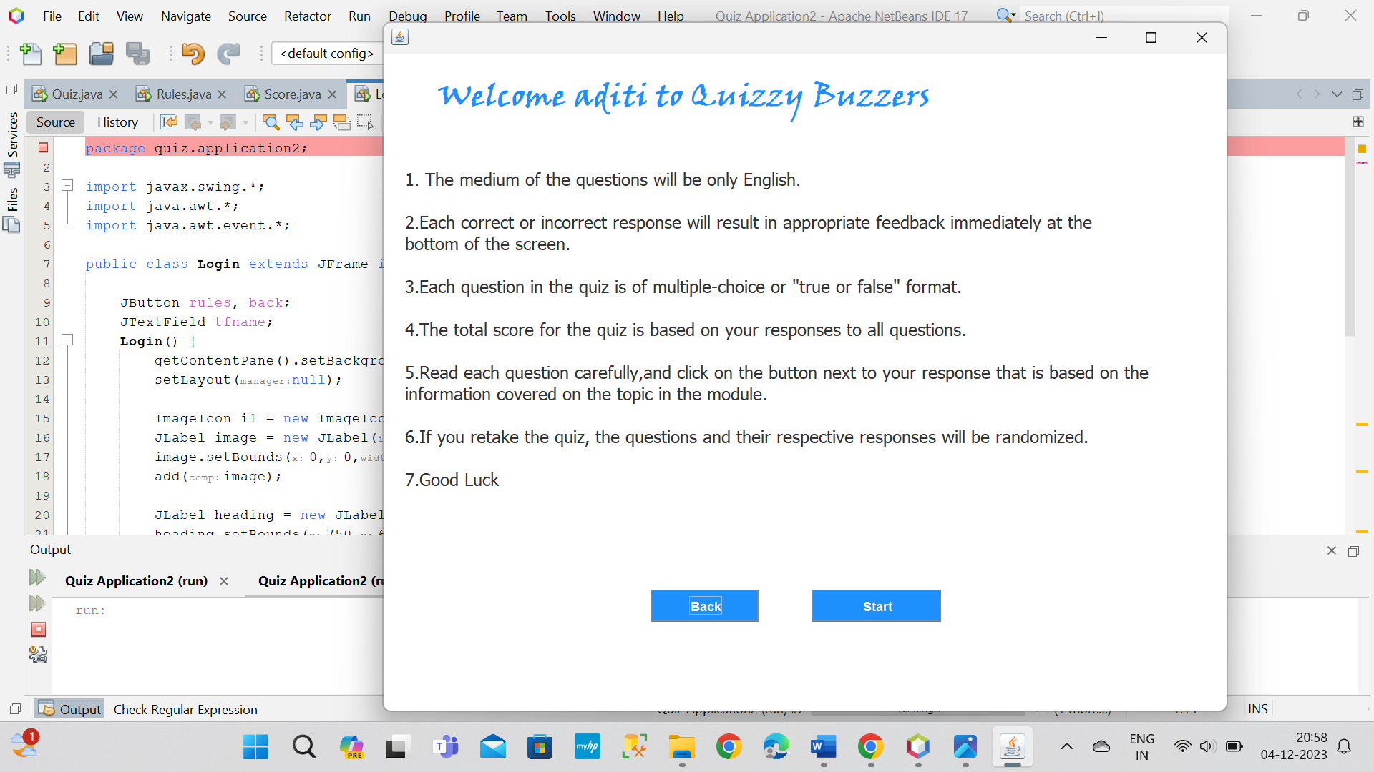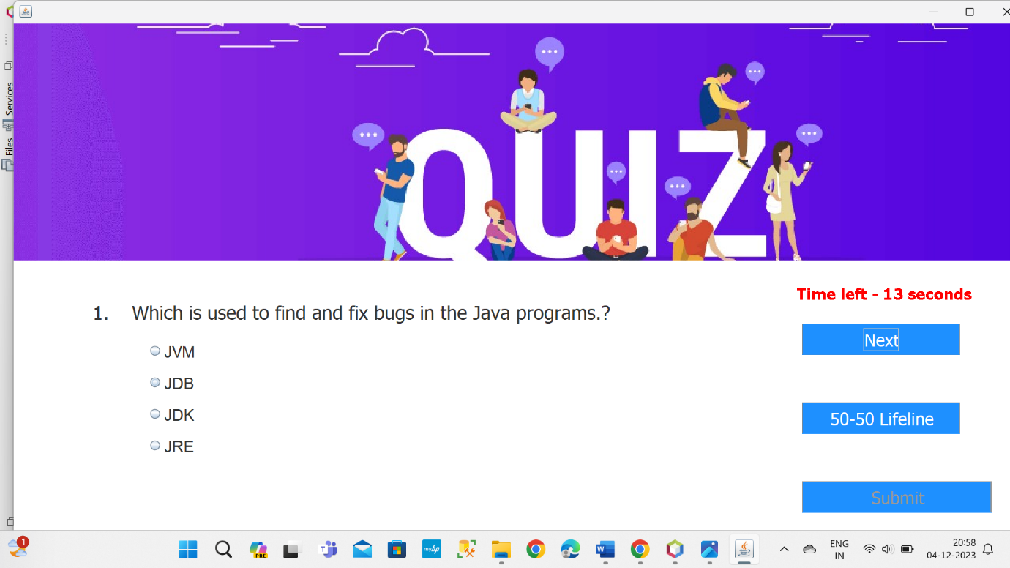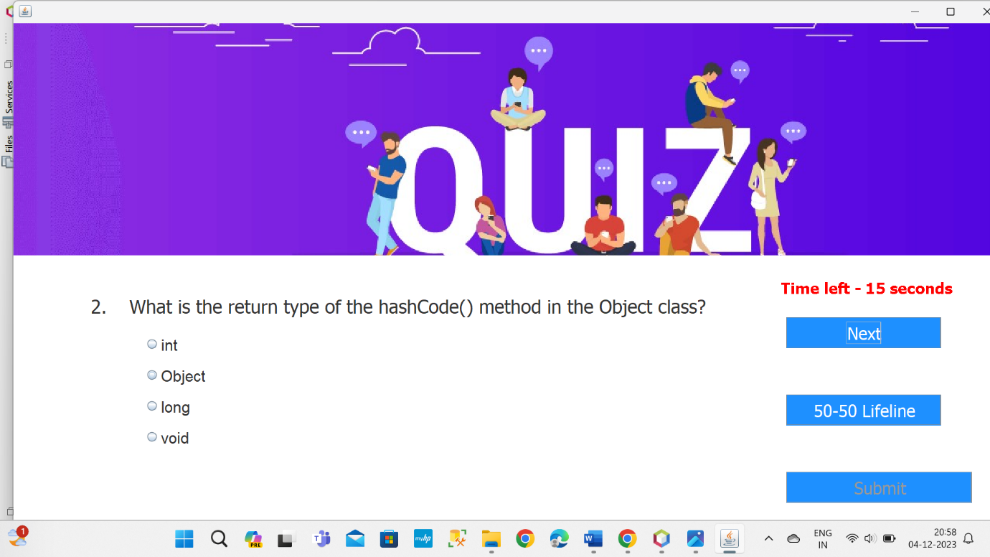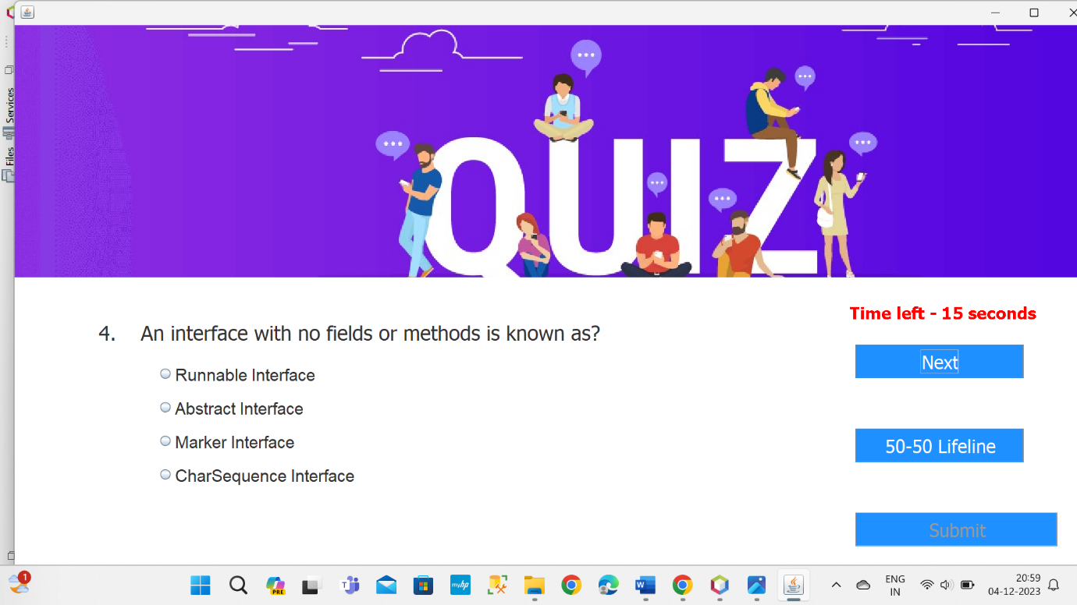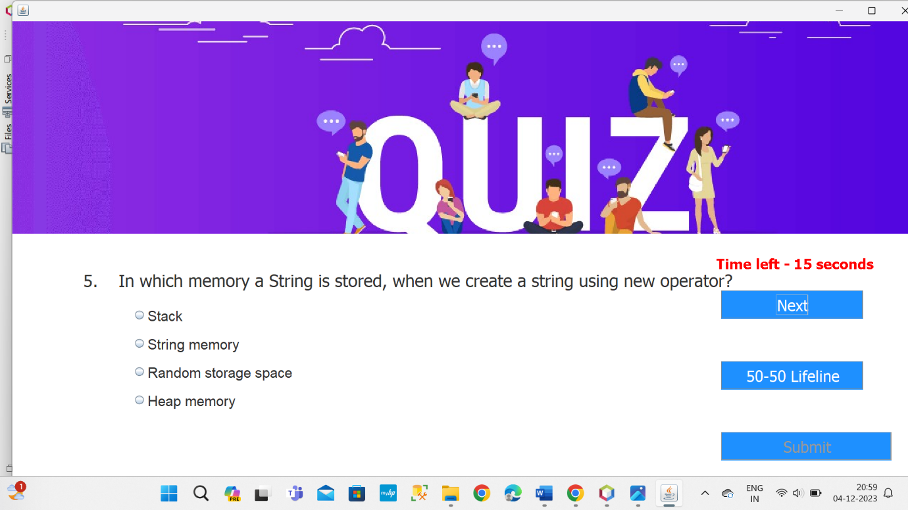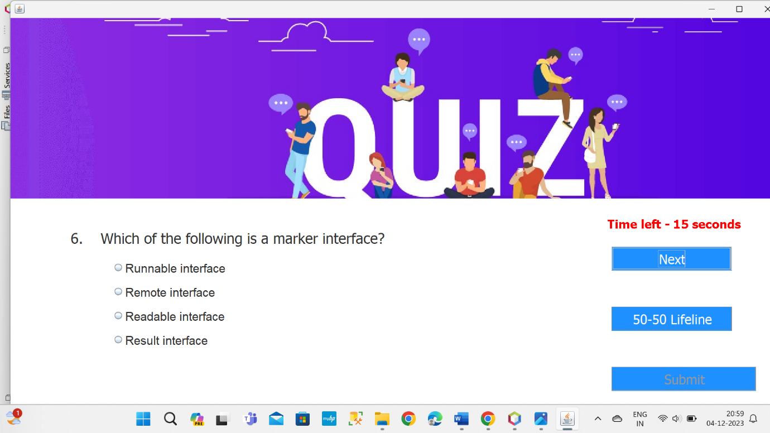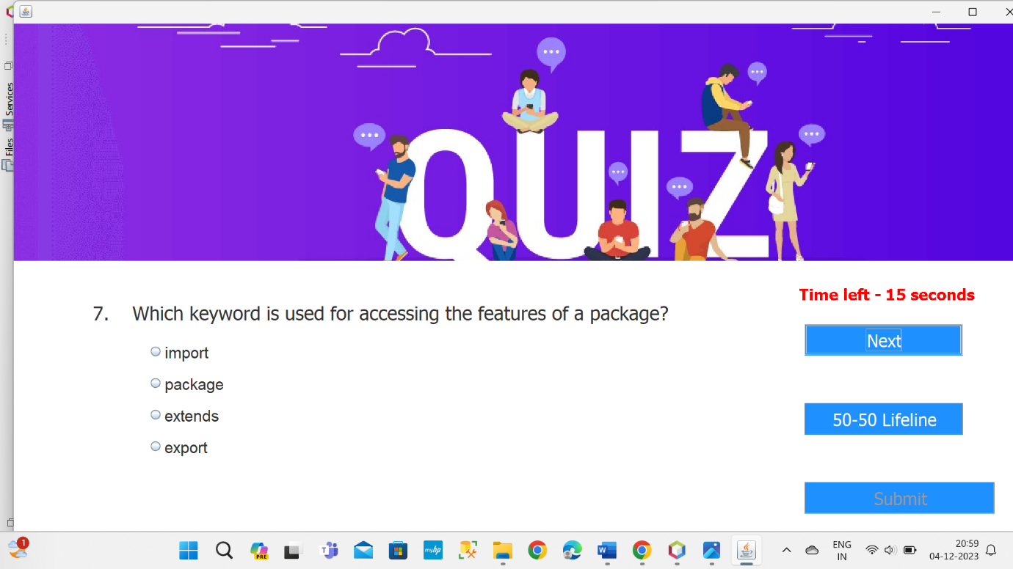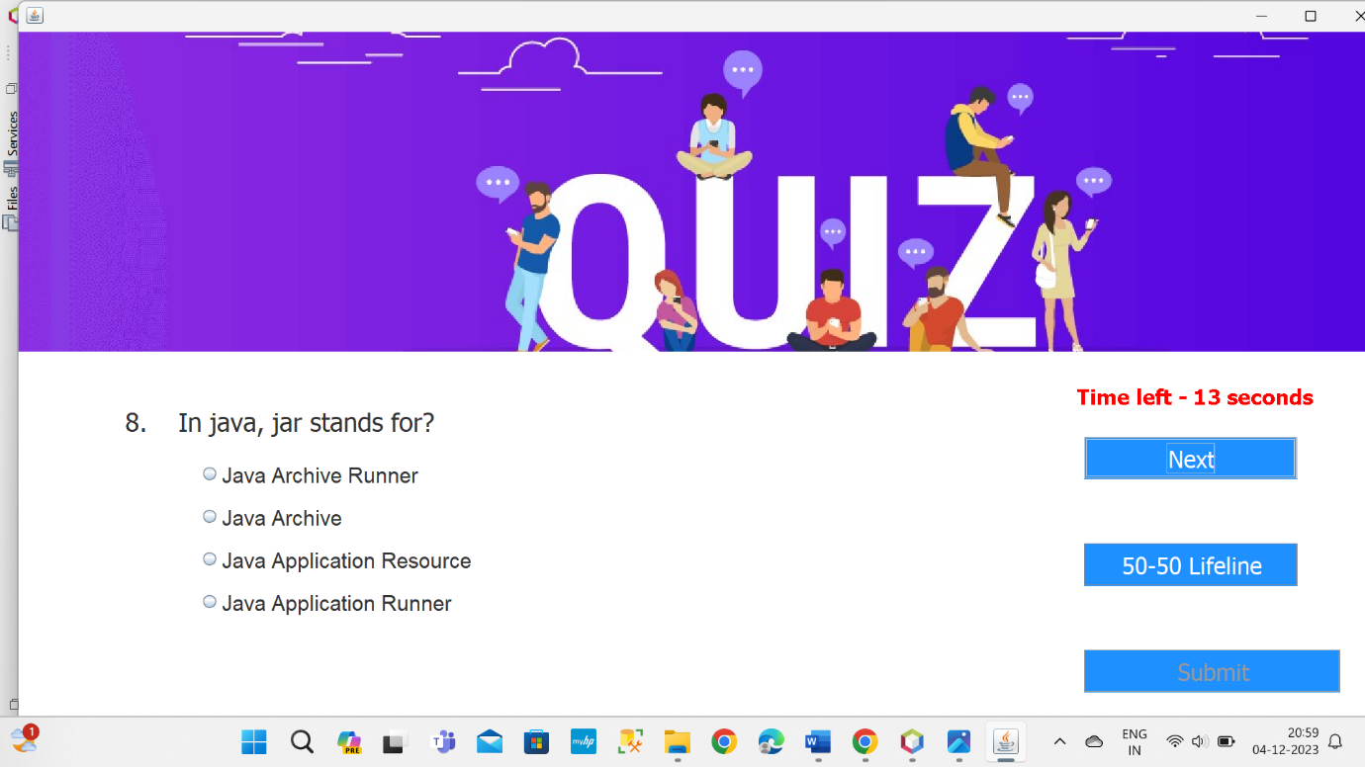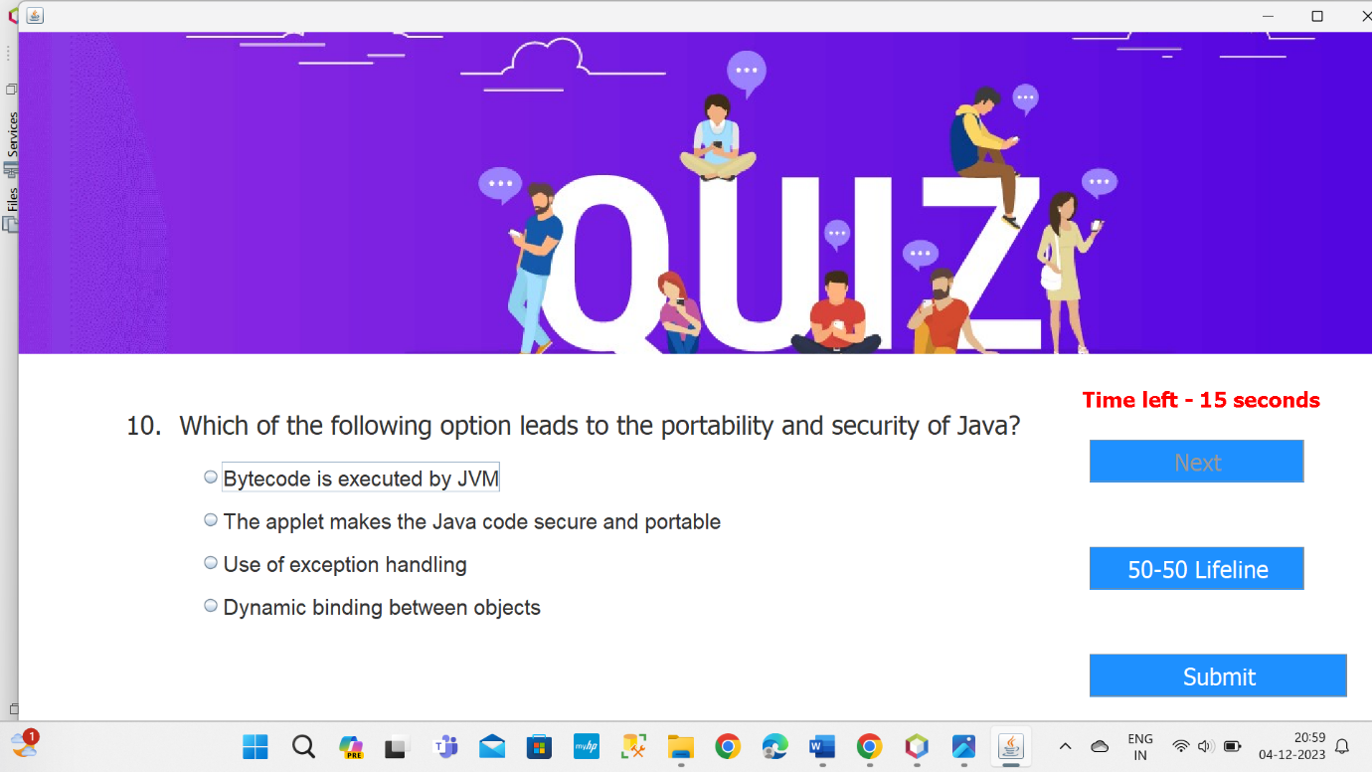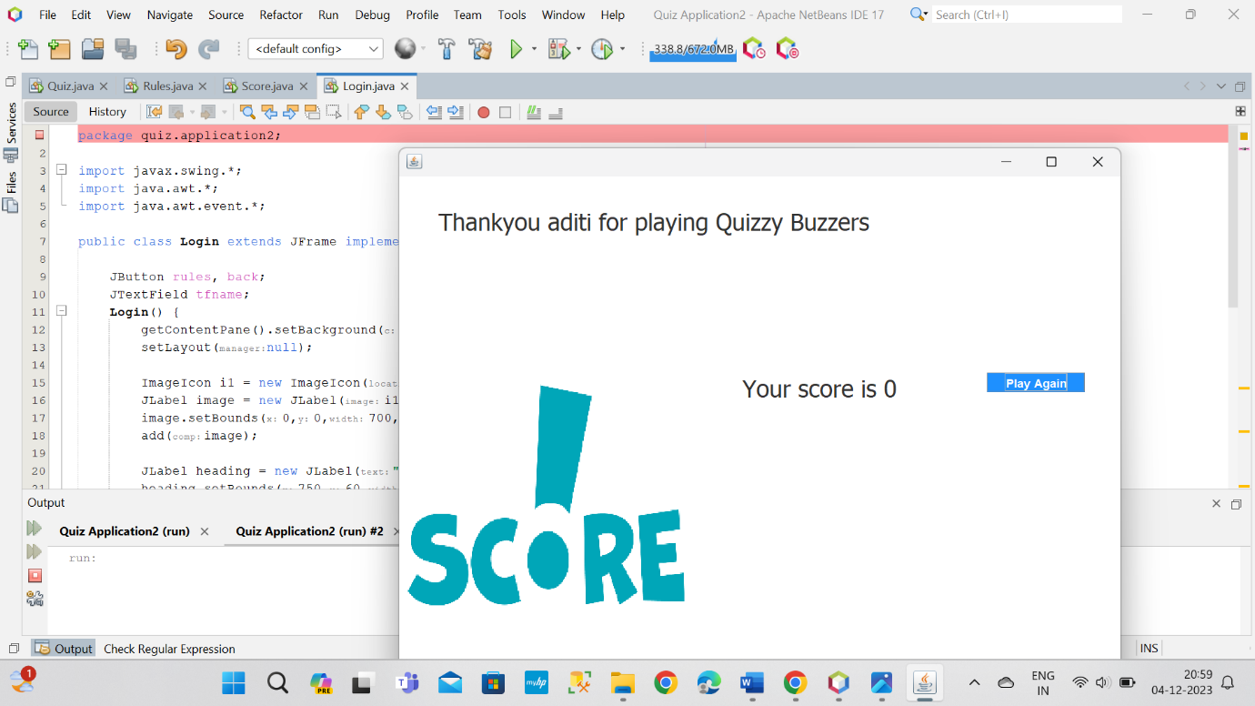

**FUTURE SCOPE**

As mentioned the project is on java platform which is coded in NetBeans IDE with help Java and running as application by Apache Netbeans. But this project is only for MCQ test but in the future we have plan to extended it to support subjective type of questions with more functionality. We will add Administrative part on it which able the system to delete test, add user, delete user and so on graphically vie the web.

To conclude, this is a simple Online MCQ Quiz which able a teacher to punch MCQ question to system which will be store in SQL Server database and able the student to attempt any test for once. The marks of student will be calculated according to questions they attempt and will be displayed by the system to teachers and student.

**CONCLUSION**

The "Quiz Application using Core Java, Swing, and AWT" provides an efficient and user-friendly platform for educators to create quizzes and for students to participate in them. By leveraging Java's robust programming capabilities and the visual appeal of Swing and AWT, the application aims to enhance the learning experience through interactive and engaging quizzes. The user-friendly interface and features like immediate feedback contribute to creating a productive educational tool for both educators and students.